**Felippe’s version of the registration form:**

1. Open <https://marketplace.auth0.com/>:
2. Click [SSO Integrations](https://marketplace.auth0.com/features/sso-integrations) in the left menu (under Features):

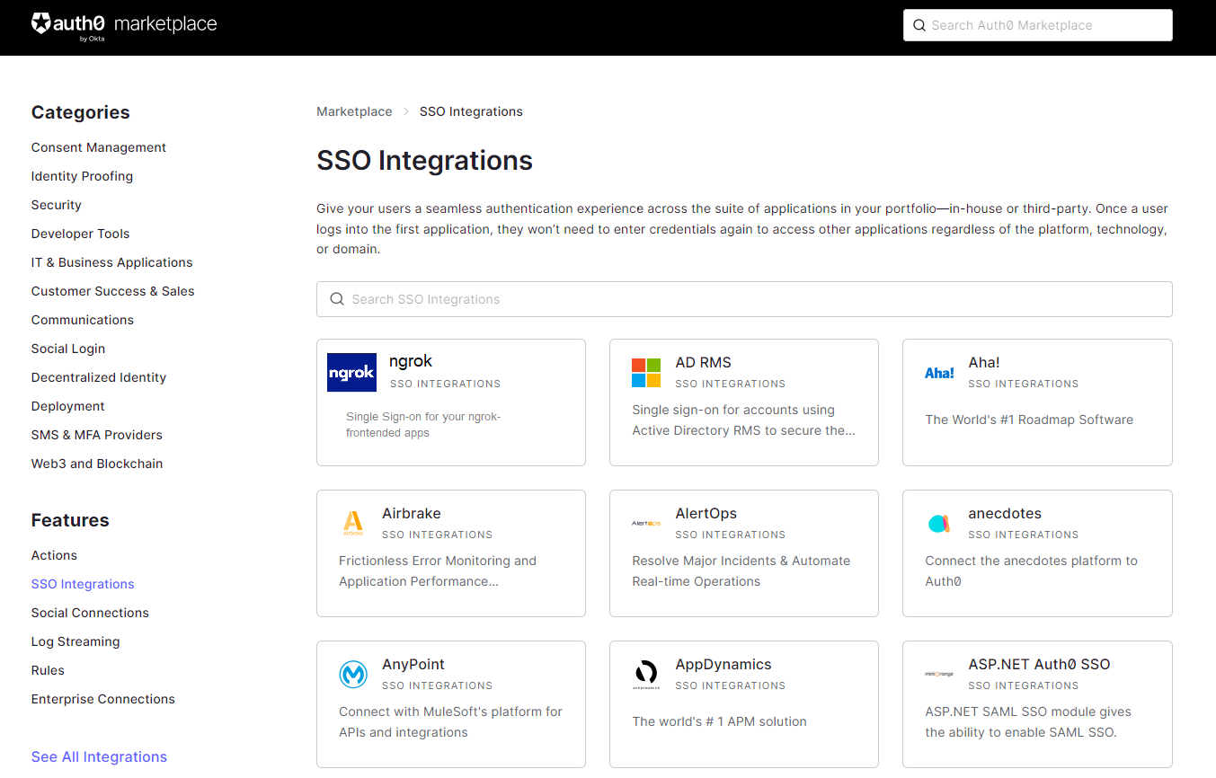

1. Click the ngrok tile:

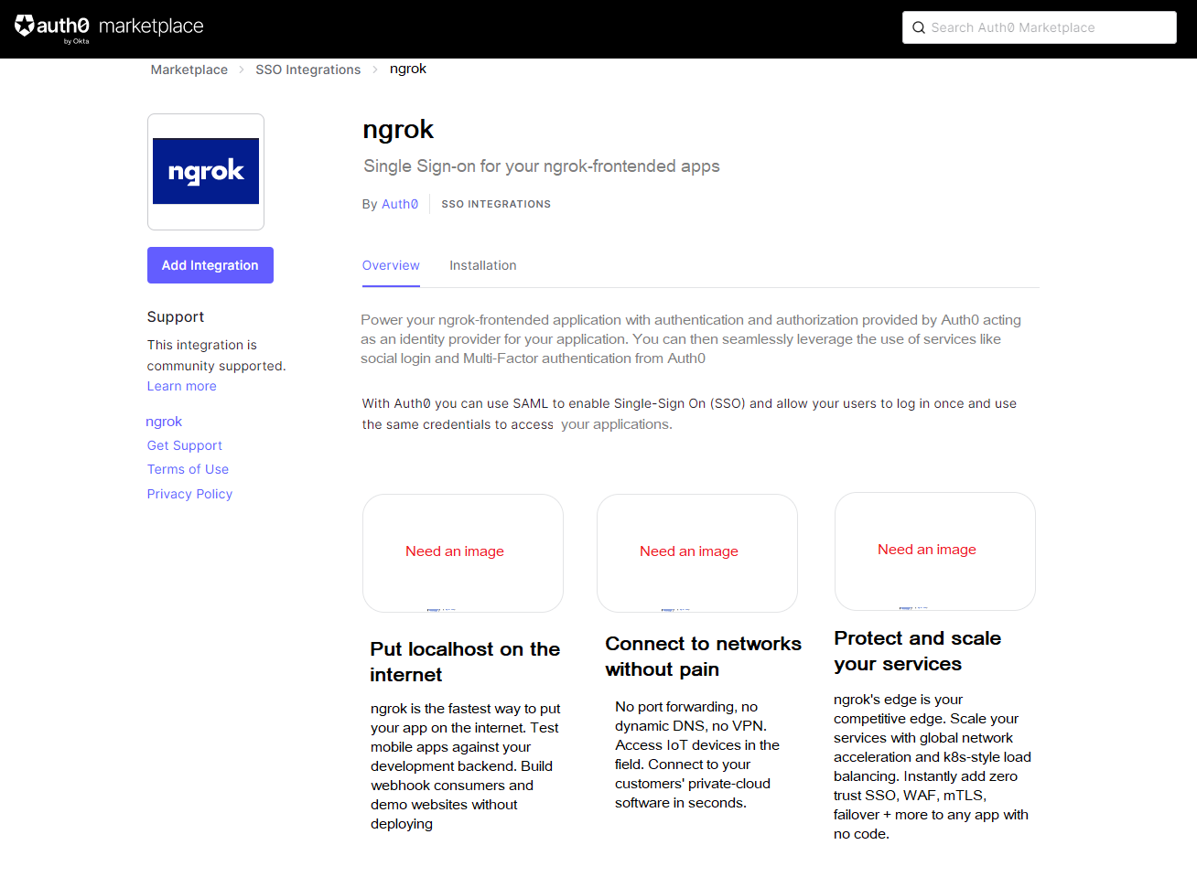

1. Click the Installation tab:  
     
   (The procedure continues down the page)

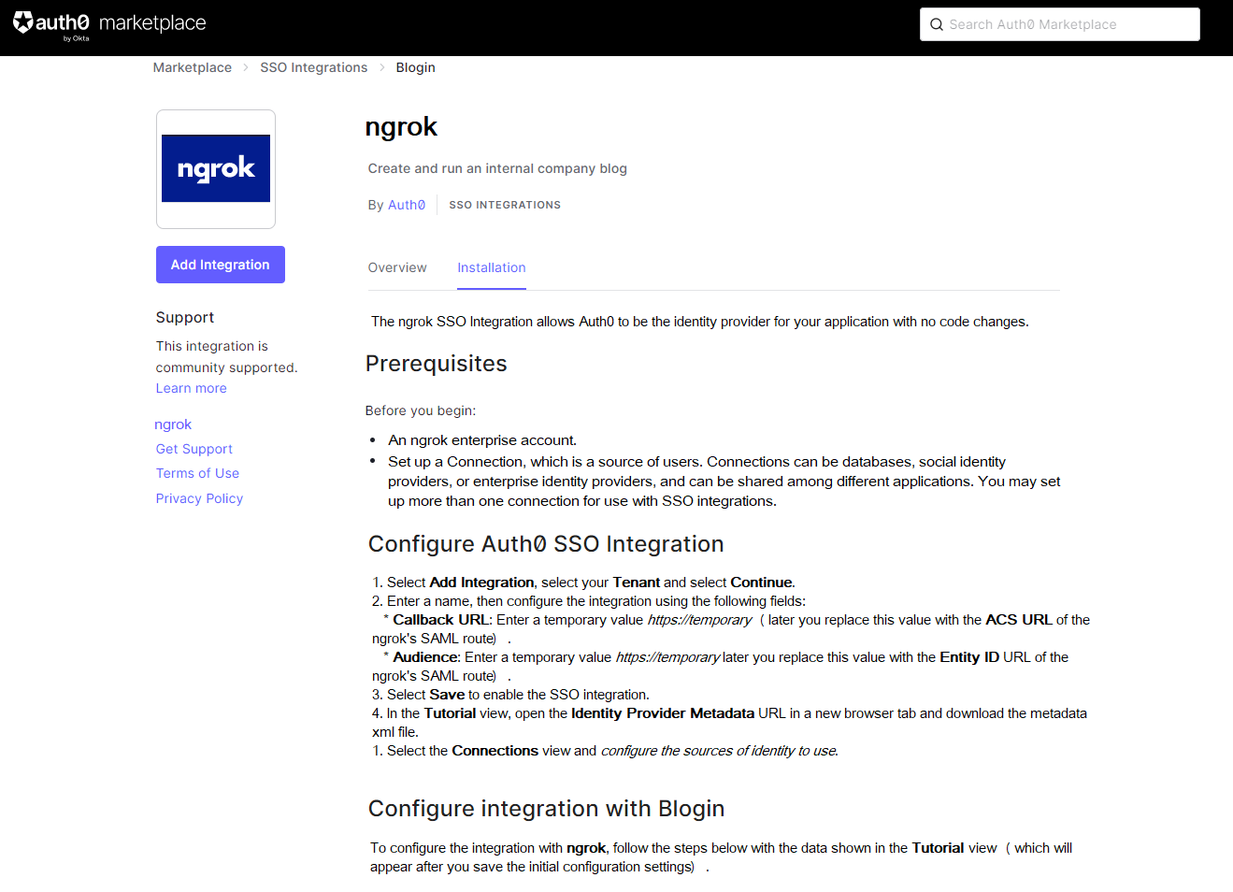

**Fred’s version of the registration form:**

1. Open <https://marketplace.auth0.com/>:
2. Click [SSO Integrations](https://marketplace.auth0.com/features/sso-integrations) in the left menu (under Features):

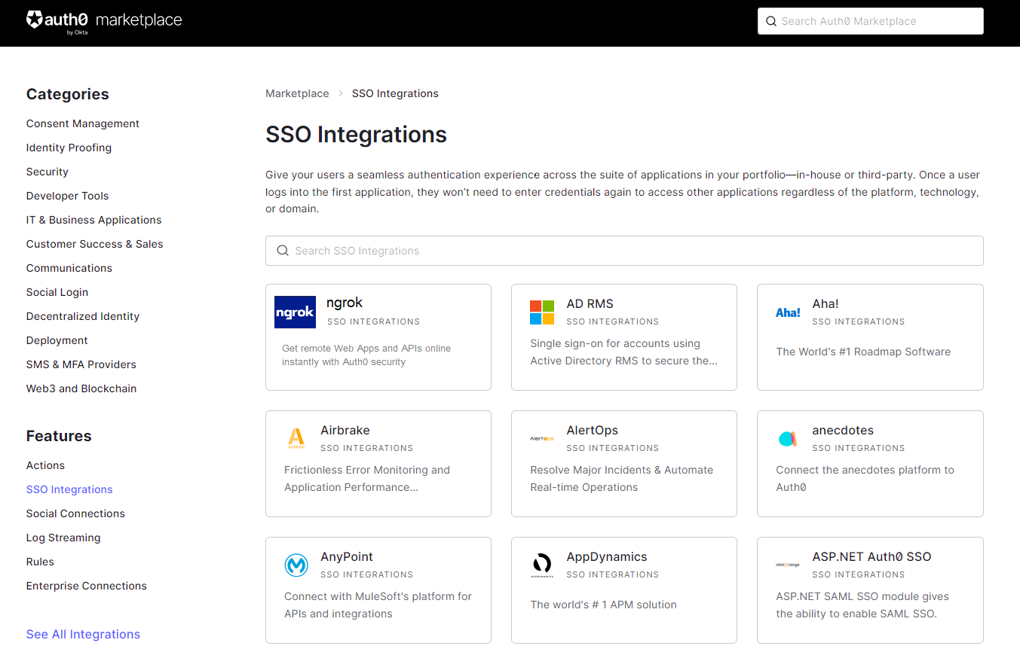

1. Click the ngrok tile:

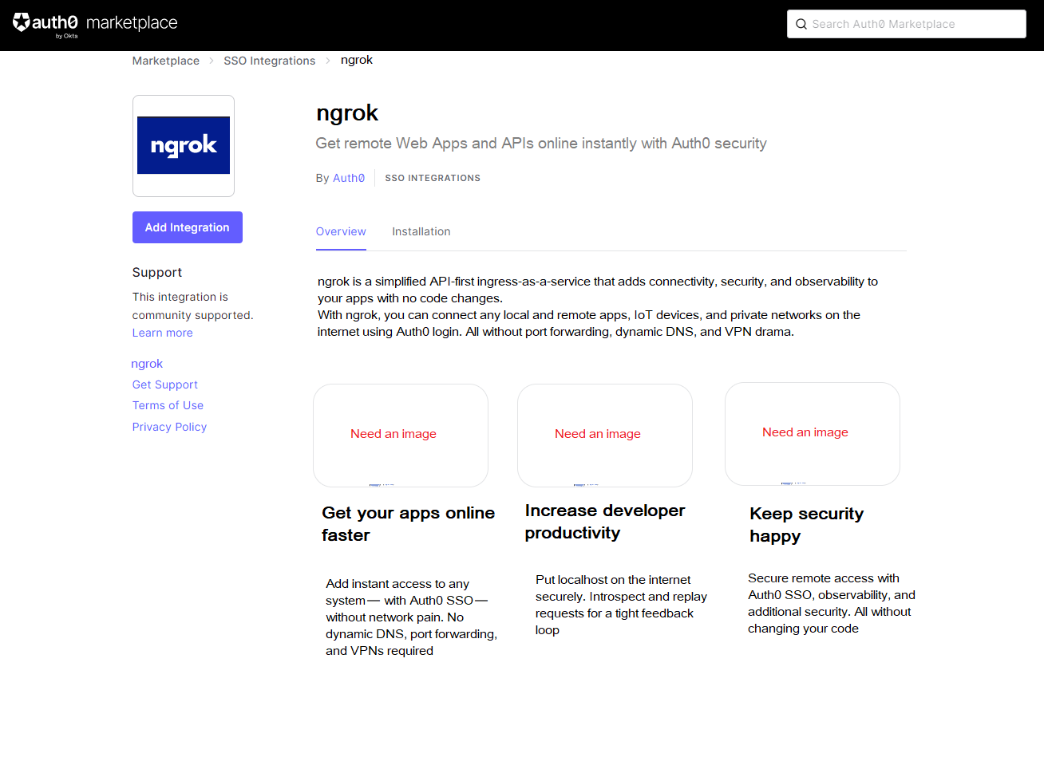

1. Click the Installation tab:  
     
   Same as Felippe’s.